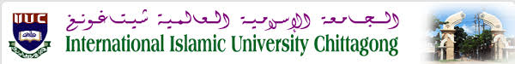 **Department of Computer Science and Engineering**

Submitted By:

|  |  |
| --- | --- |
| Student Id: | C181208 |
| Name: | Sameha Hasan |
| Section: | 8AF |
| Course Code: | CSE-4875 |
| Course Title: | Pattern Recognition and Image Processing sessional |
| Email: | samehasan25@gmail.com |

Submitted To:

Mr. Mohammad Mahadi Hassan

Associate Professor,

Dept. of CSE , IIUC.

***Lab 07:Smoothing filtering***

**- Lowpass filtering  
     - Median Filtering  
     - Max filtering  
     - Min filtering  
     - Midpoint filtering**

